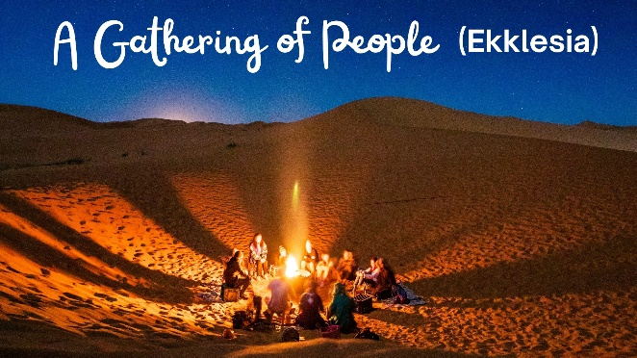
Pictures of the Church

What have I learnt from this picture?

How can I help Bethesda become more like it?

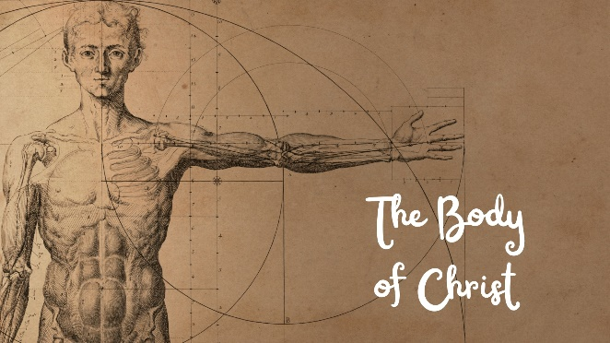
What have I learnt from this picture?

How can I help Bethesda become more like it?

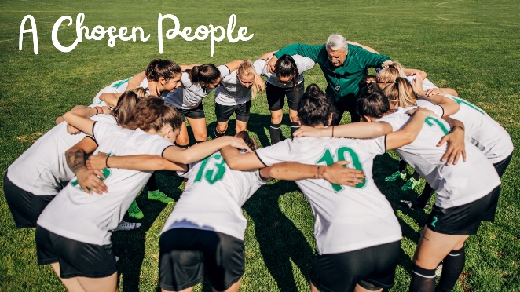
What have I learnt from this picture?

How can I help Bethesda become more like it?

What have I learnt from this picture?

How can I help Bethesda become more like it?

What have I learnt from this picture?

How can I help Bethesda become more like it?

What have I learnt from this picture?

How can I help Bethesda become more like it?

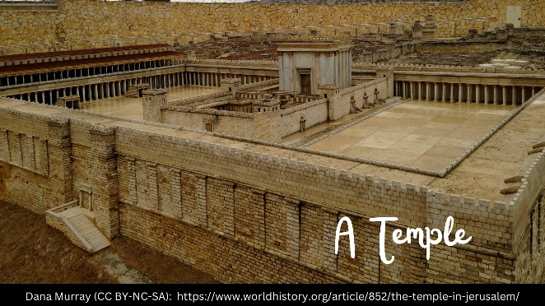
What have I learnt from this picture?

How can I help Bethesda become more like it?

What have I learnt from this picture?

How can I help Bethesda become more like it?

What have I learnt from this picture?

How can I help Bethesda become more like it?

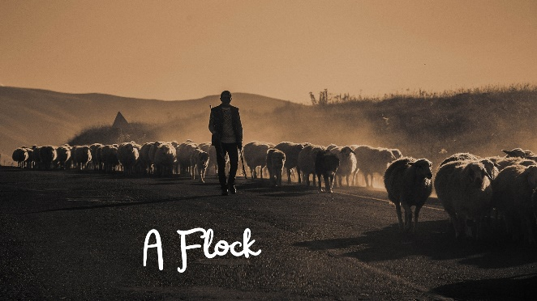
What have I learnt from this picture?

How can I help Bethesda become more like it?

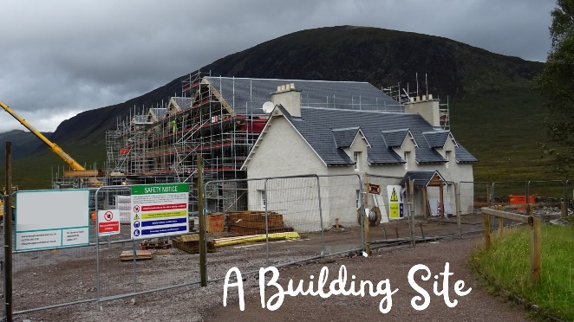
What have I learnt from this picture?

How can I help Bethesda become more like it?

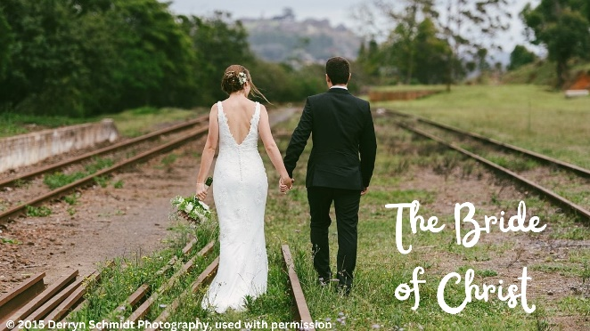
What have I learnt from this picture?

How can I help Bethesda become more like it?

